EpiData User and Group Administration.

A new model

With EpiData Manager and EntryClient 2.2 (2.1 during development) we will introduce a new optional security model for projects, to embrace the need for multiple user colaborating on projects, but where a finer control of data access is required.

The programs introduces two new concepts - Users and Groups.

The users is the personal access to a project and contains simple information, such as a name, login, password, pw. expiration date, etc.

The group is the logical contain for rights, both in regards to projectmanagment but also for allowing data access. It contains the information for the current rights, which users belongs to it and if (and what) subgroups exists.

This means that a user by default does not have any rights, but only obtains a right by belonging to a group and if the user is member multiple group, the user may obtain multiple rights.

All rights are cummulative, ie. it is not posible to set a “negative” right. If a user obtains one set of rights from group A and another set (posibly overlapping rights) from group B, the effective rights of the user is the union of the rights from group A and B.

Building a user administrated project
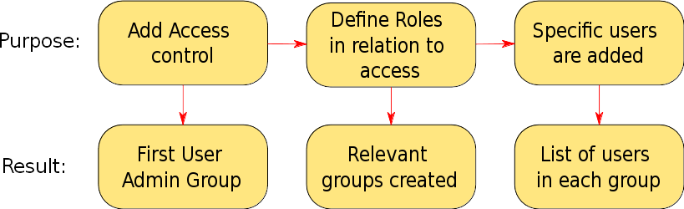
All projects starts out with no administrative setup and must be prepared by creating the first user.

Step 1: (Add Access Control)
This is done by using the menu “Project” -> “Admin...”. After the initial warning box, the first user must be created. As a minimum login and password is needed, all other information are optional.

For the access control to take effect, the project must first be save to disk, then re-opened and the user must login with the newly created identity. Now the project is setup and ready to handle multiple users and groups – they just need to be created!

Step 2: (Defining groups/roles)
It is a good strategy to create all the needed group before adding users. Especially for more complex project this step is essential as a good definition of groups will make creating and assigning users to these roles a lot less complicated. The concept of a group can be hard to comprehend, so it may be easier to think of a group as a role with a specific task. The task could be to reset password for user, another task could be to translate (still to be implemented) the project, or to do the data entry.
Again, with large and complex projects involving a lot of persons defining these roles before creating the users will in the end make maintaining the project a whole lot easier.

In EpiData Manager there exists a set of rights which can be assigned to a group. A group right effectively grant access to one specific part of Manager, that could user administration, structural design, etc. The complete list and descriptions can be seen in the appendix.

<<TODO: describe rights hierachy>>

By combining these rights it is possible to create groups with different purposes. For a local administrator user rights would be essential and perhaps the groups right would be needed too. For a group of translators, just the translate rights would be needed.

To create a new group, open the User/Group Administration window from “Project” -> “Admin”. First time this window is opened there should be a single user, namely the one created during the setup, and a single group already named “Admins”.
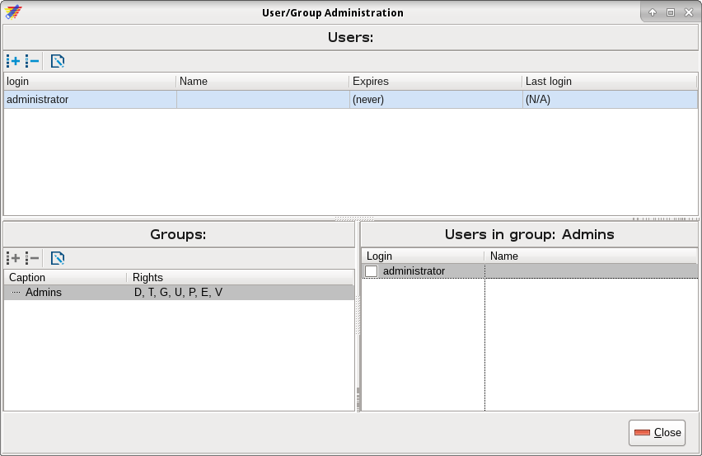
Make sure that the parent group is selected correctly, from the picture above that would be “Admins” and click the button (or use Ctrl/Cmd+G) just below the “Groups” caption. This will show a new form where management rights can be assigned to the group and it may get a caption.

<<TODO: delete, rewrite and move up
Important: Only the rights that are assigned to a group can be inherited by subgroups. Eg. if group A has rights for translate, groups, users and passwords, and B is a subgroup of A. Then B can only be assigned the same rights that A have or less, it cannot be assigned “define project”, “extended data” or “view data”.
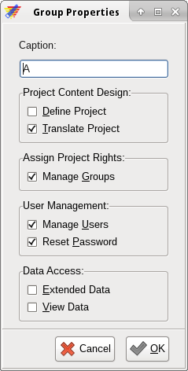
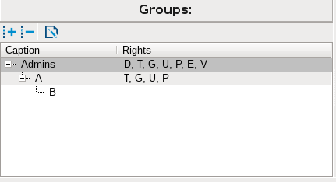
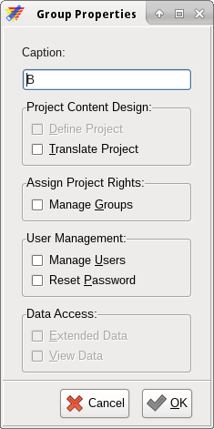

>>

Appendix:

Manager Administration Rights model:
- There will always exists a group called “Admins” and the first user created will automatically belong to this group.
- A Group is “lowest” unit to which a management right can be assigned to.
- A user with rights to manage groups, may:
  - Create and Delete subgroups to the group the user is member of.
  - Assign a (sub)set of rights to subgroups, from the set of rights assigned to the group the user is member of.
- A user with rights to manage users may:
  - Create new users
  - Delete/Edit users if the users belong to all subgroups of saig user.
  - Assign users to groups/subgroups the user belongs to.

